Topic 4.4

NOMENCLATURE AND ISOMERISM IN
ORGANIC CHEMISTRY

New Functional Groups
Review of AS Isomerism
Optical Isomerism

NEW FUNCTIONAL GROUPS

Introduction to new groups

The IUPAC method for naming organic compounds has been explained in the AS notes.

There are a number of new organic molecules in A2 Chemistry:

Type of compound | Structure of group | Example
Carboxylate salt | 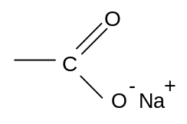 | 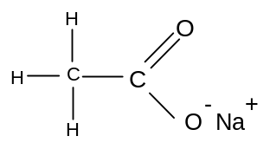
Acyl choride | 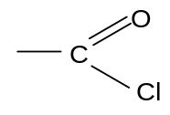 | 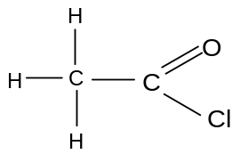
acid anhydride | 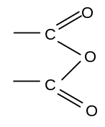 | 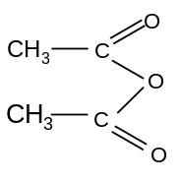
amide | 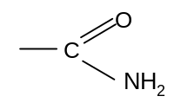 | 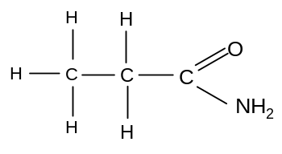
ester | 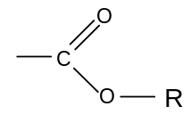 | 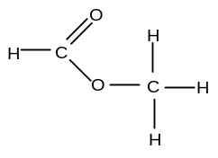
N-substituted amide | 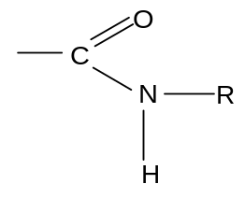 | 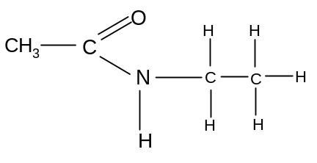

Primary amines were covered at AS-level, but there are a number of other types of amine and related molecules of which knowledge is required at A2 level:

Secondary amine | 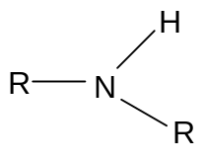 | 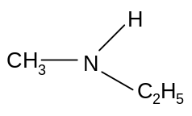
Tertiary amine | 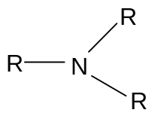 | 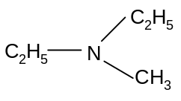
Alkyl ammonium salt | 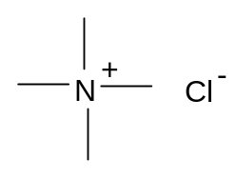 | 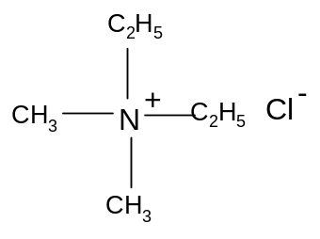

Nomenclature of new groups

a) carboxylate salts

Carboxylate salts are named with the cation first and then the suffix –anoate

Eg
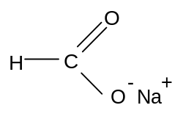
sodium methanoate

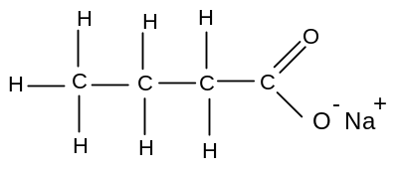
sodium butanoate

b) acyl chlorides

Acid chlorides are named using the suffix: –anoyl chloride

Eg
ethanoyl chloride
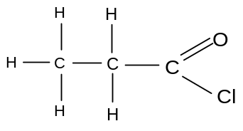propanoyl chloride

The group is always at the end of the molecule, so numbering is not necessary.

c) acid anhydrides

If both alkyl groups are the same, acid anhydrides are named using the suffix –anoic anhydride

Eg
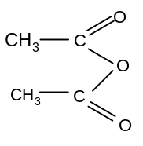ethanoic anhydride

If the alkyl groups are different, each must be specified:

Eg
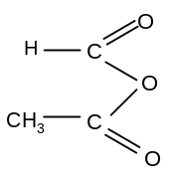methanoic ethanoic anhydride
d) amides

Amides are named using the suffix –anamide

Eg
propanamide
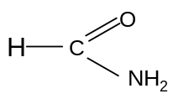 methanamide

The group is always at the end of the molecule, so numbering is not necessary.

e) esters

Esters are named using an alkyl prefix to indicate the group attached to the single O and the suffix –anoate to indicate the group attached to both oxygen atoms.

Eg
methyl methanoate

The methyl indicates the number of carbons in the chain attached to the single O (ie 1), and the methanoate indicates the number of carbons in the chain attached to both O atoms (ie 1).

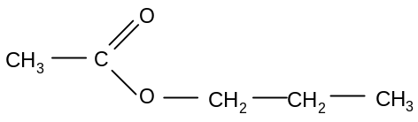 propyl ethanoate

f) N-substituted amides

N-substituted amides are named using an N-alkyl prefix to indicate the group attached to the N only and the suffix –anamide to indicate the group attached to both O and N atoms.

Eg
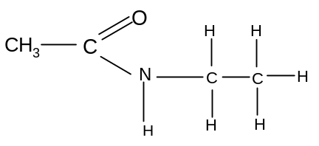 N-ethyl ethanamide

The ethyl indicates the number of carbons in the chain attached to the N only (ie 2) and the ethanamide indicates the number of carbons in the chain attached to both N and O (ie 2)

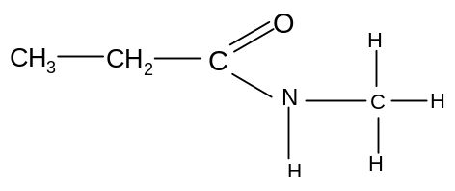 N-methyl propanamide

g) amines

Primary amines are named using the prefix amino- followed by the suffix –ane.

If the carbon chain contains more than 2 carbon atoms, the amino should be preceded by a number to indicate the position of the amino group on the chain.

Eg
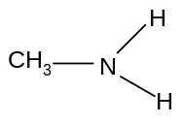 aminomethane

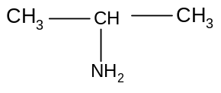 2-aminopropane
Secondary amines are named by using a N-alkyl prefix to indicate the nature of the shorter chain attached to the N atom. The longest chain is named afterwards, followed by the suffix –ane.

Eg
N-methylaminoethane

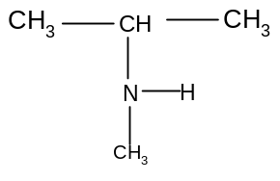 N-methyl, 2-aminopropane

Tertiary amines are named in the same way as secondary amines. The two shortest alkyl groups are indicated with a N-alkyl prefix.

Eg
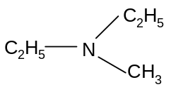 N-methyl, N-ethylaminoethane

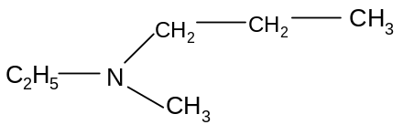 N-methyl, N-ethyl, 1-aminopropane

g) alkylammonium salts

Alkylammonium salts can be primary, secondary, tertiary or quartenary depending on the number of alkyl groups attached to the nitrogen atom. They are named simply by indicating the nature and number of each alkyl group before the ending –ammonium chloride.

Eg
dimethyldiethylammonium chloride

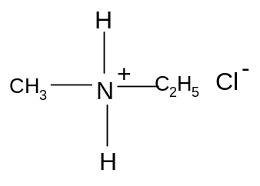methylethylammonium chloride

NOMENCLATURE OF COMPOUNDS CONTAINING MORE THAN ONE FUNCTIONAL GROUP

Many organic compounds contain more than one functional group. Naming more complex compounds such as these can be quite complicated, and only a few combinations need to be named at A-level.

- If one of the functional groups is an amine or a haloalkane, the molecule is named simply by adding the necessary prefix:

Eg
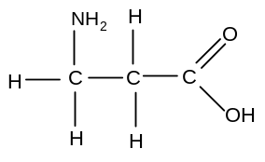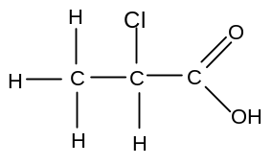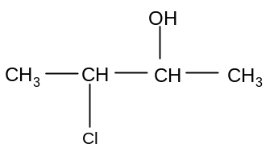
3-aminopropanoic acid 2-chloropropanoic acid 3-chlorobutan-2-ol

- If one of the functional groups is an alcohol and the other is a nitrile or anything containing a C=O bond, the alcohol group is named using a hydroxy- prefix.

Eg
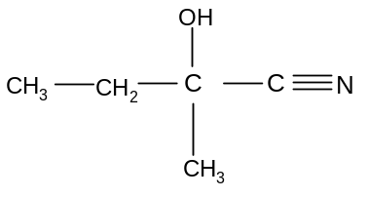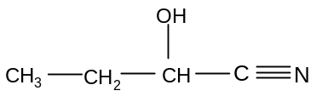

2-methyl, 2-hydroxybutanenitrile 2-hydroxybutanenitrile

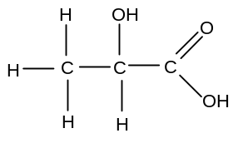
2-hydroxypropanoic acid

- If one of the functional groups is an alcohol and the other is anything other than an amine or a haloalkane, the molecule is named by replacing the –an- part of the name with –en-, including a number if the position of the alkene has to be specified.

Eg
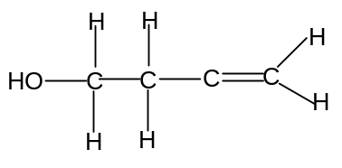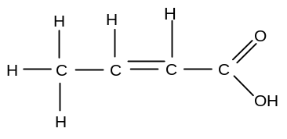
but-1-en-4-ol but-2-enoic acid

Many other organic molecules can be named in this way. The most important at A2 level are hydroxynitriles and amino acids.

ISOMERISM

Isomers are compounds with the same molecular formula but different structures.

Isomerism can be divided into two types; structural isomerism and stereoisomerism.

These in turn can be further subdivided:

There are three types of structural isomerism; positional isomerism, chain isomerism and functional isomerism.

There are two types of stereoisomerism: geometrical isomerism and optical isomerism.

The different types of isomerism are summarised in the following diagram:

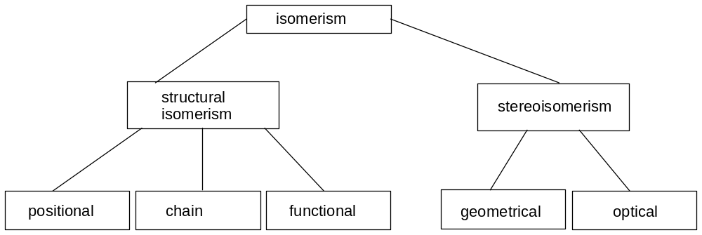

Many of these different types of isomerism were discussed in Unit 3 at AS level. Their relevance to the new types of molecule being introduced at A2 level will be briefly discussed.

a) positional isomerism

In amides, acyl chlorides and carboxylate salts, the functional group is always at the end of the molecule and so these molecules cannot show positional isomerism. The other molecules, however, can show positional isomerism:

Eg
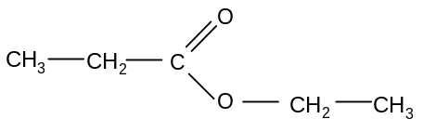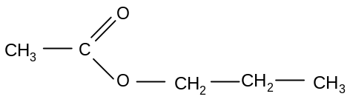
ethyl propanoate propyl ethanoate

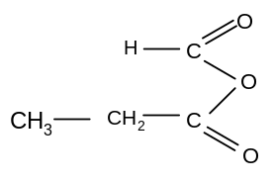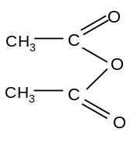
methanoic propanoic anhydride ethanoic anhydride

b) chain isomerism

All of the molecules in A2 chemistry can show chain isomerism:

Eg
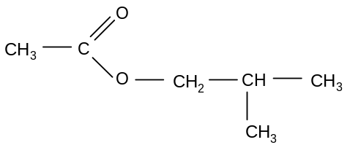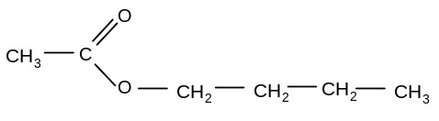
2-methylpropyl ethanoate butyl ethanoate

c) functional isomerism

In many cases, members of different homologous series can have the same general formula:

Carboxylic acids and esters have the same general formula C_{n}H_{2n}O₂.

Eg
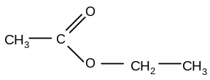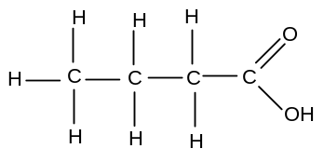
ethyl ethanoate butanoic acid

Primary, secondary and tertiary amines all have the same general formula C_{n}H_{2n+2}N.

Eg
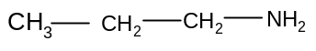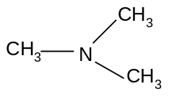
1-aminopropane N,N-dimethylaminomethane N-methylaminoethane

Other important groups which can show functional isomerism are:
- alcohols and ethers (C_{n}H_{2n+2}O)
- alkenes and cycloalkanes (C_{n}H_{2n})
- carbonyls, alkenols and cycloalcohols (C_{n}H_{2n}O)

d) E-Z isomerism

Geometrical isomerism was introduced at AS-level. It occurs in alkenes when both carbon atoms forming the double bond are attached to two different groups.

Eg
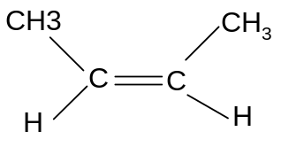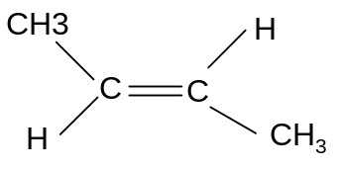
Z but-2-ene E but-2-ene
In a double bond, the second bond is a π-bond. This is caused by the side-on overlap of two p-orbitals:
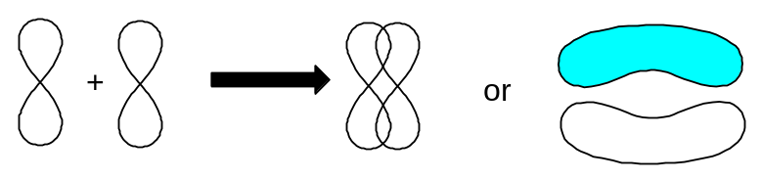
The result is an overlap in two places. This means that the bond cannot be twisted and as a result there is restricted rotation about the π-bond. This is why the cis and trans isomers cannot be interconverted and are therefore different.
e) optical isomerism

Optical isomerism is not required for AS-level. It will thus be explained in detail here.

i) Introduction

Consider the following molecule:

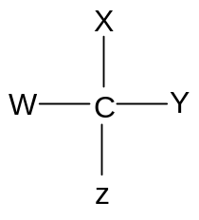

It is tetrahedral and is thus more accurately represented in the following way:

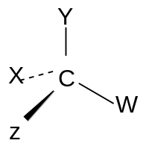

Since the carbon atom is attached to four different groups, it is asymmetric and so cannot be superimposed on its mirror image:

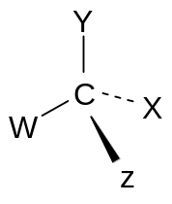

These two mirror images cannot be interconverted without breaking covalent bonds.

Molecules which contain a carbon atom which is attached to four different groups are said to be chiral. Chiral molecules cannot be superimposed on their mirror image.

The two non-superimposable mirror images are optical isomers or enantiomers.
Any molecule which contains at least one carbon atom attached to four different groups will thus exhibit optical isomerism.

Consider the four structural isomers of C₄H₉Cl:

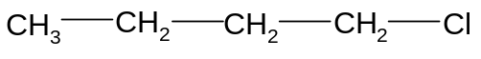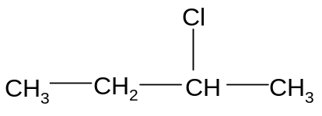
1-chlorobutane 2-chlorobutane

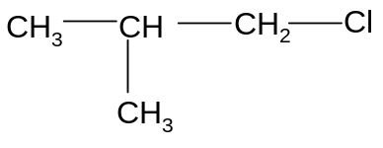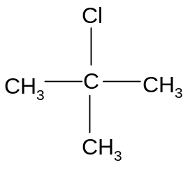
1-chloro, 2-methylpropane 2-chloro, 2-methylpropane

Of these molecules only 2-chlorobutane shows optical isomerism:

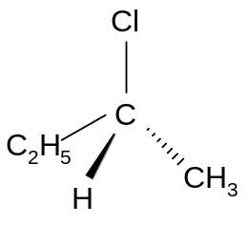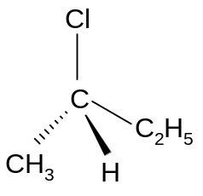

ii) Distinguishing between the different enantiomers

Optical isomers show identical physical and chemical properties in most respects.
In fact there is only one physical method by which they can be distinguished.

Plane-polarised light is light which has been filtered into a two-dimensional plane:

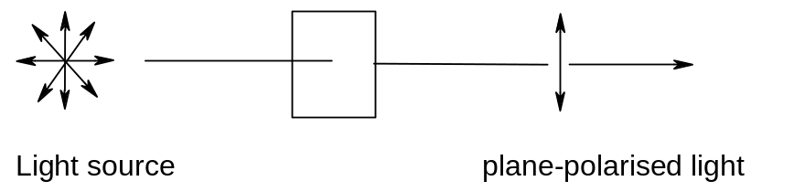

If plane-polarised light is passed through a liquid containing a chiral molecule, the plane of the light will be rotated. This can be detected using a polarimeter.

Molecules which are not chiral will not rotate the plane of plane-polarised light.

Chiral molecules will rotate plane-polarised light. Two optical isomers will rotate plane polarised light equally, but in opposite directions.
It is this difference in physical properties which enables them to be distinguished.

It is not possible to predict the direction in which a particular optical isomer will rotate plane polarised light, but two optical isomers will always rotate plane polarised light in opposite directions.

A substance which can rotate plane polarised light is said to be optically active.

The isomer which rotates plane polarised light clockwise is given the prefix (+) or D-. The isomer which rotates plane polarised light anticlockwise is given the prefix (-) or L-.

iii) Importance of optical isomers in biochemistry

Optical isomers show identical chemical properties in most reactions. However, certain biochemical processes require the molecule to have a specific orientation of groups. Many drugs and enzymes are chiral and so only one of the optical isomers will be able to interact effectively with the target molecule in the body. Different optical isomers may therefore have very different biochemical effects.

iv) racemates

Optical isomers are often found together in a mixture in equal quantities. The opposite effect they have on the rotation of plane polarised light will thus result in no overall rotation. An equimolar mixture of two optical isomers will thus have no effect on plane polarised light and is thus not optically active.
Such mixtures are said to be racemic mixtures or racemates.

A racemic mixture is an equimolar mixture of two optical isomers. Racemic mixtures are not optically active.

Thus chiral molecules will only show optical activity if one isomer is present in greater quantities than the other.

It is possible to predict whether a single enantiomer or a racemate will be produced, provided that the mechanism for the reaction is known.

If the chiral substance is produced by an addition reaction, then the product will always be a racemate as the attacking nucleophile or electrophile can attack the planar molecule from above or below with equal probability:

Eg formation of 2-bromobutane from but-2-ene (electrophilic addition)

The bromide ion can attack the carbocation from above or below, producing an equimolar mixture of the two enantiomers – ie a racemate:

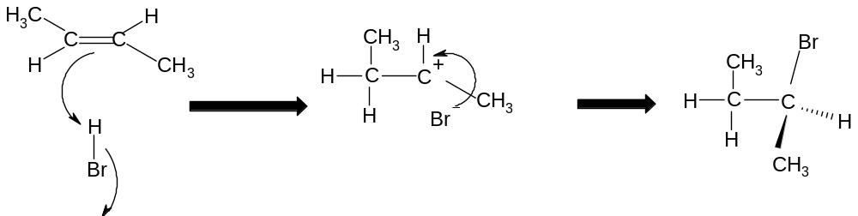
bromide attacks planar species from above

or
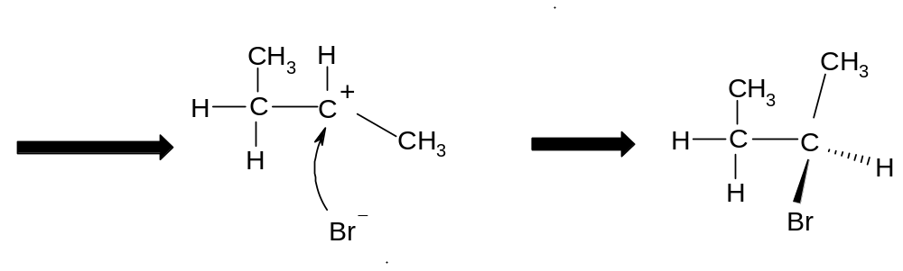
bromide attacks planar spcies from below

Nucleophilic addition reactions also produce racemates for the same reason. In the preparation of the chiral molecule 2-hydroxypropanenitrile from ethanal for example, the cyanide ion can attack the planar carbonyl group from above or below, producing a racemate.

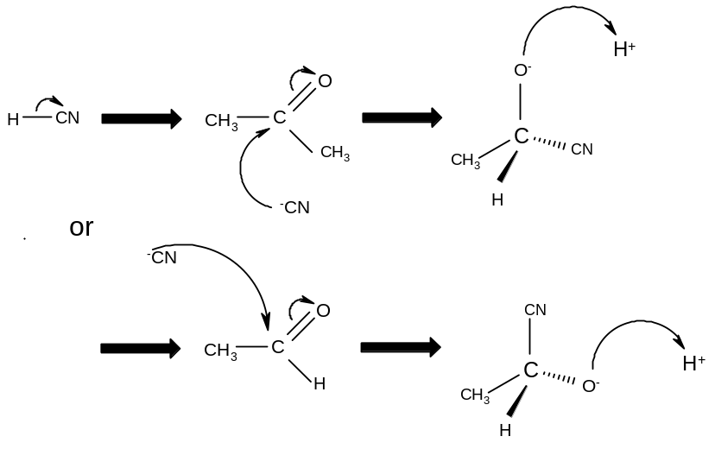

If the chiral molecule is produced by a substitution reaction and the starting molecule is a single enantiomer, then the attacking species can only attack from one side and a single enantiomer will be produced.

Eg preparation of butan-2-ol from 2-bromobutane

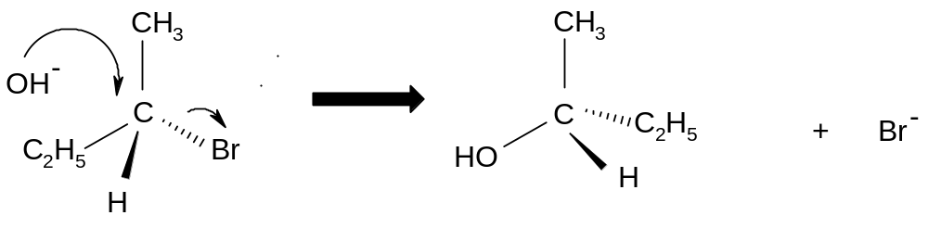

The hydroxide ion always attacks from behind, always producing the same enantiomer.

So nucleophilic substitution reactions produce single enantiomers provided that the substrate was also a single enantiomer. Nucleophilic and and electrophilic addition reactions always produce racemates.

